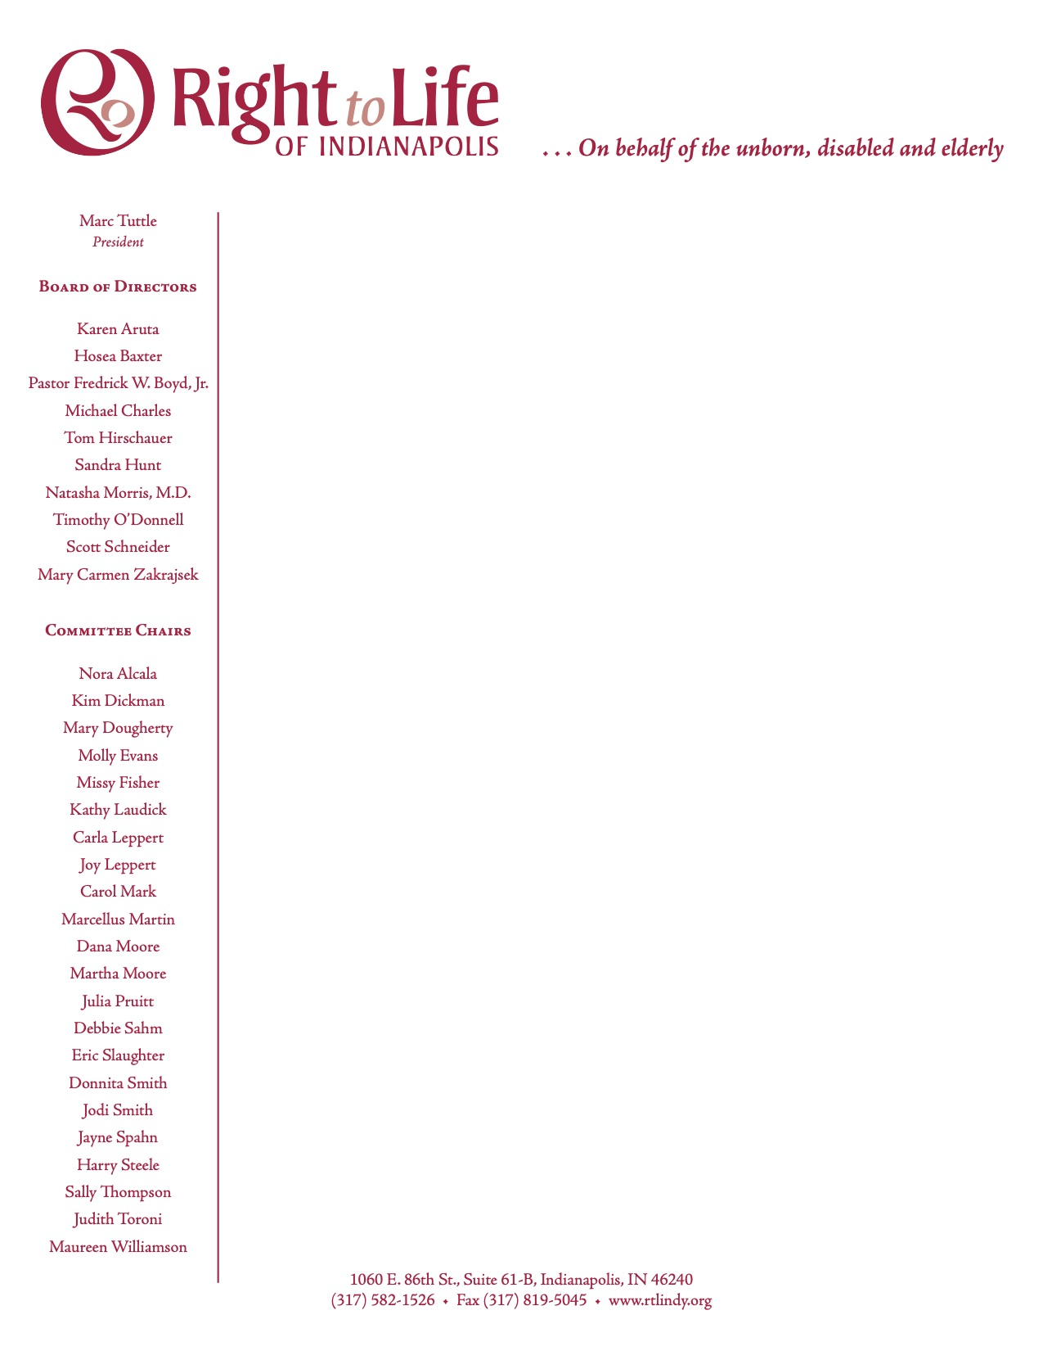

RIGHT TO LIFE OF INDIANAPOLIS
2024 JUNIOR HIGH SCHOOL STUDENT ESSAY CONTESTS

What: Junior High School Essay Contest

When: Entry Deadline: April 1, 2024
Who: All 7th and 8th grade students
Private, public and home school students

Each student entry must have a sponsoring organization, such as:
Church

School
Home School Organization
The sponsoring organization must be located in Marion County or one of the seven bordering counties. We are asking for a contact person with each entry.

Each sponsoring organization will select one winning entry from each of its 7th grade classrooms entering and one from each of its 8th grade classrooms entering. ONE winning essay from each classroom should be sent by April 1, 2024 to:

Right to Life of Indianapolis
Essay Contest
1060 East 86th Street Suite 61B
Indianapolis, Indiana 46240

Please label each winning entry as follows:

RIGHT TO LIFE OF INDIANAPOLIS
JUNIOR HIGH ESSAY CONTESTS 2024

STUDENT NAME ______________________________________
STUDENT SIGNATURE ________________________________
HOME ADDRESS ______________________________________
CITY_____________________, IN ZIP CODE __________
EMAIL ADDRESS______________________________________
PHONE (____) ________________ H ( ) _________________C
GRADE LEVEL _____ Parent’s Name _____________________

Check only one sponsoring organization:
o CHURCH NAME ______________________________________
o SCHOOL NAME _______________________________________
o SPONSORING ORGANIZATION ________________________
Teacher/Contact person____________________________________
Contact person’s phone_____________________________________
Contact person’s e-mail____________________________________

