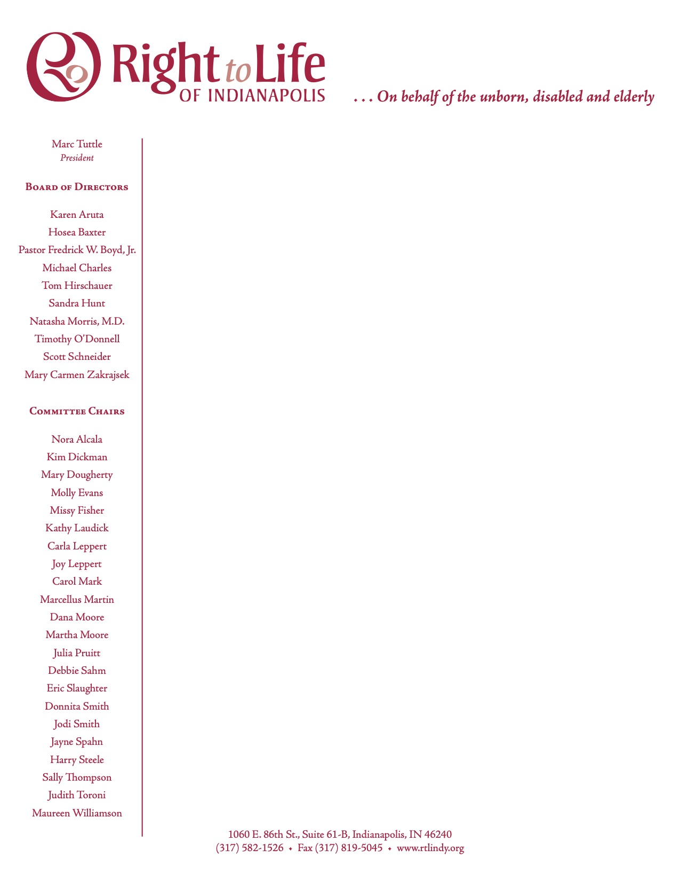

RIGHT TO LIFE OF INDIANAPOLIS
2024 HIGH SCHOOL STUDENT ESSAY CONTEST

What: High School Essay Contests

When: Entry Deadline: April 1, 2024
Who: All high school students
Private, public and home school students

Each student entry must have a sponsoring organization, such as:
Church

School
Home School Organization
The sponsoring organization must be located in Marion County or one of the seven bordering counties. We are asking for a contact person with each entry.

Each sponsoring organization may select one winning entry from each of its 9th and 10th grade classes entering and one winning essay from each of its 11th and 12th grade classes entering. ONE winning essay from each classroom should be sent by April 1, 2024 to:

Right to Life of Indianapolis
Essay Contest
1060 East 86th Street Suite 61B
Indianapolis, Indiana 46240

Please label each winning entry as follows:

RIGHT TO LIFE OF INDIANAPOLIS
HIGH SCHOOL ESSAY CONTEST 2024

STUDENT NAME ______________________________________
STUDENT SIGNATURE ________________________________ HOME ADDRESS ______________________________________
CITY ____________________, IN ZIP CODE____________
EMAIL ADDRESS ______________________________________
PHONE (____) _______________H ( ) __________________C
GRADE LEVEL _____ Parent’s Name ______________________

Check only one sponsoring organization:
o CHURCH NAME ______________________________________
o SCHOOL NAME _______________________________________
o NAME OF SPONSORING ORGANIZATION _______________
_________________________________________________________
Teacher/Contact person____________________________________
Contact person’s phone __________________________________________
Contact person’s email ____________________________________

